Project Development Phase
Model Performance Test

Date | 30 September 2026
Team ID | SWTID-2026-2091
Project Name | Implement Client Script & UI Policy (Incident)
Maximum Marks | 10 Marks

Model Performance Testing:
Project team shall fill the following information in model performance testing template.
S.No. | Parameter | Values | Screenshot
 | Metrics | Regression Model:  MAE - Not Applicable, MSE - Not Applicable , RMSE - Not Applicable , R2 score - Not Applicable  Classification Model:  Confusion Matrix - Not Applicable , Accuray Score- Not Applicable & Classification Report - Not Applicable | 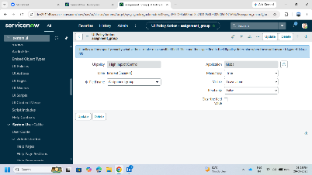
 | Tune the Model | Hyperparameter Tuning - Not Applicable  Validation Method - Not Applicable | 